Employee Portal
System Design & Workflow Document

1. Overview
This document defines the system design for an employee self-service portal covering attendance, leave, payroll, performance, documents, and HR support, with a role-based access model that restricts employee data changes to HR/Admin approval.

2. Roles & Access Model
Three roles cover this system:
- Employee — view own profile, apply leave, check-in/out, download own payslip/ID card, upload own documents (pending HR verification), raise tickets, give feedback, submit resignation.
- HR / Admin — full CRUD on employee records, approve/reject leave and resignation, upload payslips, manage announcements/policies/holidays, verify uploaded documents, manage performance review cycles.
- Manager (optional, if a reporting hierarchy exists) — approve team leave, view team attendance, conduct performance reviews for direct reports.

Key rule: employees have read-only access to their own master data (name, designation, salary structure, bank details, etc.). Any change to that data goes through an edit-request workflow — the employee submits a change request, HR/Admin reviews it, and the system updates the record only on approval, with every change logged.

2.1 Row-level isolation for self-service actions
For the modules where employees do act directly — attendance, leave, tickets, feedback, resignation, document upload — access is scoped to the employee's own records only. An employee can never view, edit, or approve another employee's attendance, leave, payslip, documents, or performance data. This must be enforced at the API layer, not just hidden in the UI:
- Every API request carries the authenticated user's employee_id from the JWT/session, never from a client-supplied parameter.
- All self-service queries (attendance, leave, tickets, etc.) are automatically filtered WHERE employee_id = current_user.employee_id — the employee cannot pass a different ID to see someone else's record.
- Approval actions (approve/reject leave, resolve tickets, verify documents) are permitted only for the HR/Admin or Manager role, checked server-side on every request — not inferred from what buttons the UI happens to show.
- The Employee Directory is the one place employees see other employees' basic info, and it is explicitly read-only with a restricted field set (name, designation, department, contact) — never salary, bank details, or documents.
In short: self-service means “act on your own record,” never “act on anyone's record.” HR/Admin (and Managers, where applicable) are the only roles whose access spans multiple employees, and even then only for the fields their role requires.

3. System Architecture
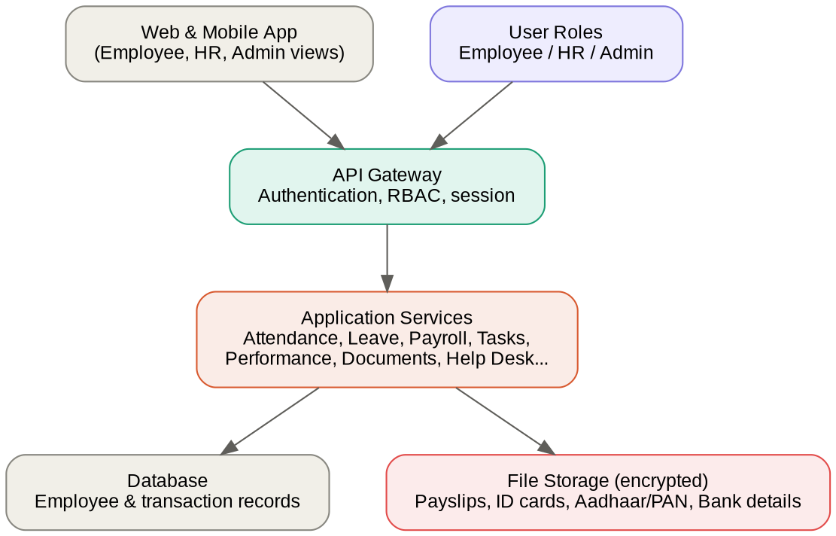
Figure 1: Four-tier architecture — client apps, API gateway with auth/RBAC, application services, and the data layer.

4. Database Design
Core entities and their key fields:
Table | Key fields
Users | id, email, password_hash, role, status
Employees | id, user_id (FK), name, DOB, designation, department, manager_id, joining_date, employment_status
Attendance | id, employee_id (FK), date, check_in_time, check_out_time, status
Leave_Applications | id, employee_id (FK), leave_type, from_date, to_date, reason, status, approved_by
Payslips | id, employee_id (FK), month, year, file_url, generated_by
Documents | id, employee_id (FK), doc_type (Aadhaar/PAN/Bank), file_url, verification_status
Announcements | id, title, content, posted_by, visible_to
Holidays | id, date, name, applicable_locations
Tasks_Projects | id, project_name, assigned_to, deadline, status
Performance_Reviews | id, employee_id (FK), reviewer_id (FK), cycle, rating, comments
Training_Materials | id, title, file_url, category
Policies_Documents | id, title, file_url, category
HelpDesk_Tickets | id, employee_id (FK), category, description, status, assigned_to
Resignation_Requests | id, employee_id (FK), notice_date, last_working_day, status, approved_by
Feedback | id, employee_id (nullable), message, category
Change_Requests | id, employee_id (FK), field_name, old_value, new_value, status, reviewed_by
Audit_Log | id, actor_id (FK), action, entity, entity_id, timestamp

Change_Requests and Audit_Log are the two tables that enforce and record the access-control rule in Section 2 — every employee-initiated edit becomes a row in Change_Requests, and every HR/Admin action against employee data is written to Audit_Log.

5. Entity Relationship Diagram
See the landscape page at the end of this document for the full ERD.

6. Access-Control Workflow: Employee Data Changes
An employee can view their master data but never edit it directly. Any correction (address, bank account, name spelling, etc.) goes through a request-and-approval cycle. Attendance, leave, tickets, and feedback are the exception — those remain employee-initiated by design.
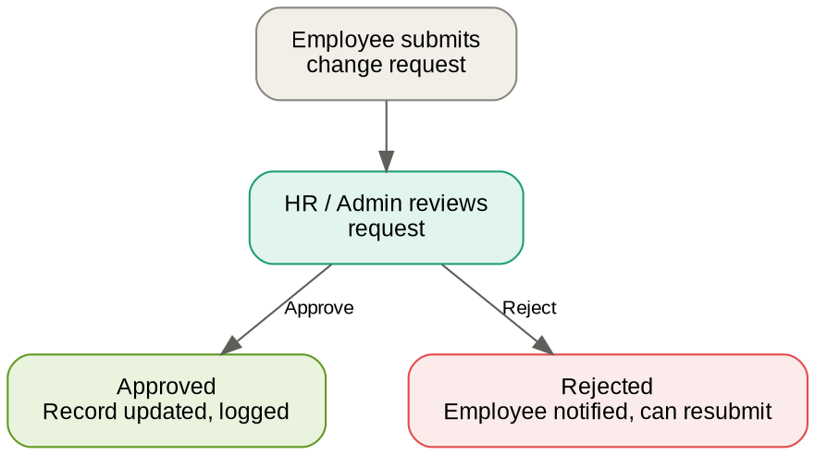
Figure 2: Employee data change-request workflow.
This same submit → review → approve/reject pattern applies to resignation requests and leave applications too — substitute “Manager” for “HR/Admin” if a reporting-hierarchy approval step is wanted for leave.

7. Module-wise Access Matrix
Module | Employee | HR / Admin
Profile view | Own only | All
Profile edit | Request only | Direct edit + approve requests
Attendance | Check-in/out own | View/edit all, run reports
Leave | Apply, view own status | Approve/reject, view all
Payslip | Download own | Generate/upload for all
Announcements / notice board | View | Create/edit/delete
Holiday calendar | View | Create/edit
Tasks / projects | View/update assigned tasks | Assign, track, close
Performance reviews | View own, self-assessment | Conduct reviews, finalize ratings
Training materials | View/download | Upload/manage
Policies | View | Upload/manage
ID card | Download own | Generate/reissue
Help desk | Raise/view own tickets | View/resolve all tickets
Directory | View all, limited fields only (read-only) | Manage entries, full fields
Resignation | Submit request | Approve/reject, initiate offboarding
Feedback | Submit | View/respond (optionally anonymous)
Document upload | Upload own (Aadhaar/PAN/bank) | Verify/reject uploaded docs
Password / security | Manage own | Reset for locked-out users

8. Suggested Tech Stack
- Frontend: React (or Next.js) — SPA/PWA for mobile-responsive access.
- Backend: Node.js (Express/NestJS) or Django/Spring Boot — REST or GraphQL API.
- Database: PostgreSQL, with S3-compatible storage for documents/payslips/ID cards.
- Auth: JWT-based sessions with role claims; consider 2FA for HR/Admin accounts given sensitive data access.
- File storage: encryption at rest for Aadhaar/PAN/bank details, with access logging from day one.

9. Key Design Decisions
- Manager role or not — if a reporting hierarchy exists, route leave/performance approvals to the manager first, then HR for policy compliance; otherwise HR handles everything directly.
- Anonymous feedback — decide upfront whether the Feedback module supports anonymity, since it affects the data model (nullable employee_id).
- Document verification states — Aadhaar/PAN/bank uploads should carry a status (pending/verified/rejected) so HR can flag mismatches before they cause payroll errors.
- Audit logging — every HR/Admin edit to employee data should be logged (who changed what, when), since this is core to the access-control requirement.

Appendix: Full Entity Relationship Diagram
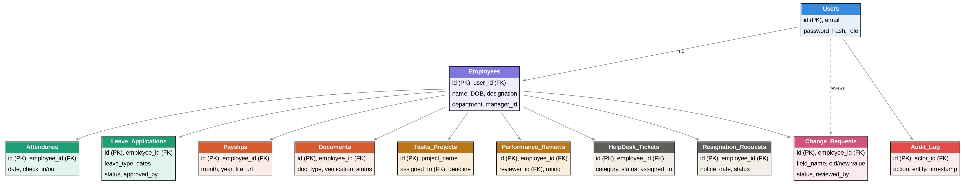
Figure 3: Full database ERD showing Employees as the central entity with related modules.

